

**INFO 5707.022 - DATA MODELLING FOR INFORMATION PROFESSIONALS**

**TITLE: HEALTH INSURANCE CLAIM MANAGEMENT SYSTEM**

**Term Project Final Report**

**Instructor – Dr. Ali Sahara**

**SEMESTER - FALL 2024**

**GROUP-1**

**TEAM MEMBERS:**

Nannapaneni Sai Bhavana (Team Co-ordinator)

Nivas Kapilavai Vishwanath

Naveed Shaik

Jeevan Chandaka

Lakshmi Prasanna Kommineni

1. **Objectives and Scope**

**1.1 Overview**

The primary objective of this project is to develop a robust database management system designed to efficiently process and manage data, ultimately delivering reliable services for customers seeking to claim their health insurance policies. Additionally, the system aims to empower the organization in optimizing its departmental operations and enhancing overall productivity.

**1.2 Key Objectives**

**Systematic Data Storage and Organization**

* The system will implement a structured approach to store and organize data in a way that ensures easy accessibility across all departments.
* Data management practices will be improved through systematic organization and standardized procedures.
* Interdepartmental workflows will be streamlined through efficient data organization and access protocols.

**Efficient Data Retrieval**

* Users will be able to quickly and intuitively access information through an optimized retrieval system.
* The decision-making process will be enhanced through immediate access to relevant data.
* Time spent on information searches will be significantly reduced through efficient indexing and search capabilities.

**Accuracy and Consistency**

* High data quality will be maintained through comprehensive validation checks throughout the system.
* Data redundancy will be prevented through careful database design and optimization.
* The system will implement safeguards against data entry errors to ensure information reliability.
* Information consistency will be maintained through automated validation processes.

**1.3 Enterprise-Level Functionality**

**Claims Processing**

* The system will facilitate the tracking of claims from initiation through to final resolution.
* Claim documentation will be managed efficiently through automated workflows.
* Status updates will be automatically generated and distributed to relevant stakeholders.

**Policy Management**

* Comprehensive tools will be provided for managing the complete policy lifecycle.
* The system will support policy creation, updates, and renewals through automated processes.
* Policy status tracking will be automated to ensure accurate management.

**Customer Interaction**

* The customer experience will be enhanced through simplified access to policy information.
* Policy and claim information will be presented transparently to all users.
* A user-friendly interface will facilitate efficient policy management.

**Payment Processing**

* All transactions will be processed with complete accuracy through automated systems.
* Payment tracking will be automated to ensure proper financial management.
* Financial management will be integrated across all system components.

**2. User Requirements**

**Claims Management**

* The database will track and analyse customer claim history to inform decisions about new policies.
* The system will automate all manual calculations to improve efficiency and accuracy.
* Users will be able to retrieve stored data quickly through an intuitive interface.

**System Access and Security**

* The database will support concurrent access by multiple users without experiencing deadlocks.
* Access to information will be limited based on user roles and responsibilities within the system.
* The system will implement secure and role-based access controls for all database operations.
* Personal information will be protected through robust authentication mechanisms.
* A comprehensive audit log will track and monitor all transactions for transparency.

**Policy Administration**

* The system will suggest appropriate policies based on customer specifications such as age and employment type.
* Customer details, policy information, and transaction logs will be managed with complete accuracy.
* Commission calculations will be performed automatically based on each agent's performance metrics.
* Policy updates and modifications will be tracked through detailed logging systems.

**Payment Management**

* Users will have the ability to arrange their payment schedules according to their preferred methods.
* Multiple payment methods will be supported to accommodate various user preferences.
* Payment history and dues will be tracked systematically for all accounts.
* The system will generate detailed breakdowns of expenditures across different time periods.

**3. Business Rules**

**Policy Management Rules**

* Every policyholder must maintain at least one active policy to be eligible for filing claims.
* Multiple claims may be filed for each policy, provided they correspond to events during the active coverage period.
* Policy renewal options will be available either automatically or manually according to policyholder preferences.
* Late payments will incur penalties or interest charges as specified in the policyholder's contract.

**Agent Operations Rules**

* Each policy will be assigned to a specific agent who will manage customer inquiries and updates.
* Agents will earn commissions based on their successful policy sales and renewals.
* The system will notify agents of any policy cancellations or significant changes requested by policyholders.
* Agents will be responsible for maintaining clear communication channels with their assigned policyholders.

**Claims Processing Rules**

* All claims must undergo a complete approval process before payment authorization.
* Claim payments will be subject to policy terms, deductibles, and specified limits.
* Claims may be linked to multiple health treatments or services when appropriate.
* Payments will be directed either to service providers or policyholders based on claim specifications.
* Each treatment must be verified as a necessary service before payment processing can begin.

**4. Entity Relationship Diagram (ERD):**

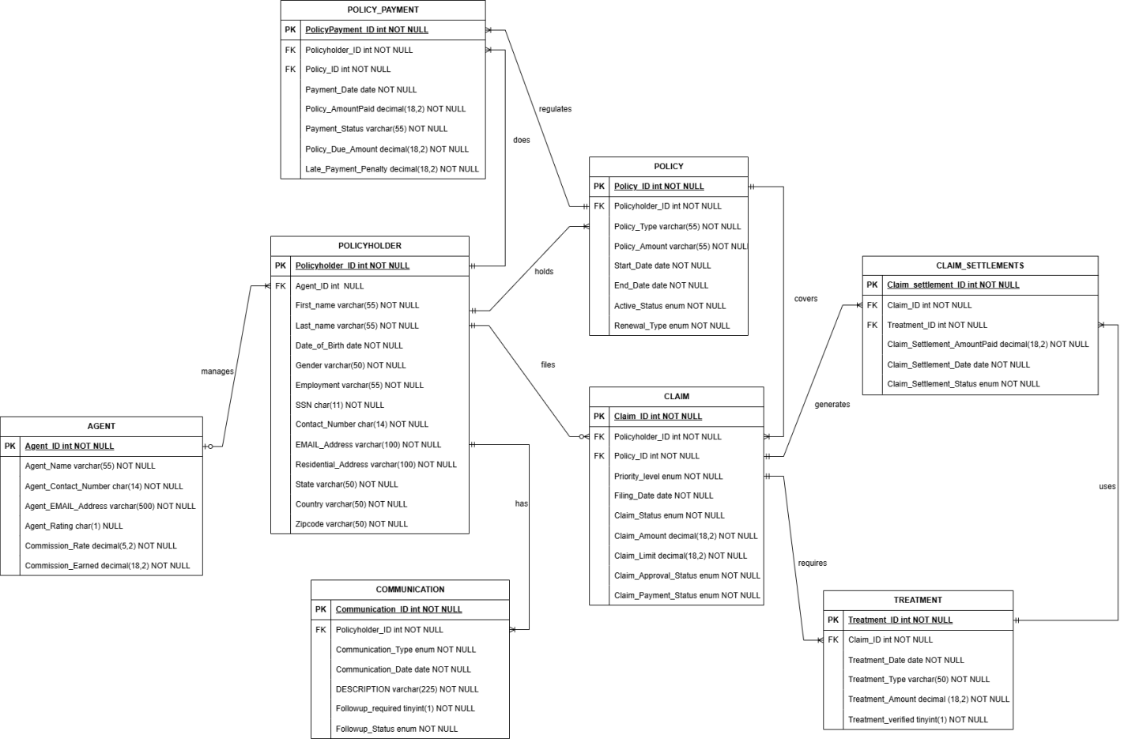

The Entity Relationship Diagram illustrates the complex relationships between eight primary entities in our insurance claim management system:

**Primary Entities and Relationships**

**Agent Entity**

* The Agent entity serves as a central management point with attributes including Agent_ID (PK), Agent_name, Agent_Contact_number, Agent_emailaddress, and Agent_rating.
* Agents manage multiple policyholders through a one-to-many relationship.

**Policyholder Entity**

* The Policyholder entity contains comprehensive personal information with Policyholder_ID as the primary key.
* A policyholder holds policies (one-to-many relationship), files claims (one-to-many relationship), and is managed by an agent (many-to-one relationship).
* Essential attributes include personal details such as name, date of birth, gender, contact information, and SSN.

**Policy Entity**

* The Policy entity tracks insurance coverage details with Policy_ID as the primary key.
* Each policy belongs to one policyholder (many-to-one relationship).
* The entity includes critical information such as policy type, amount, and validity dates.

**Claim Entity**

* The Claim entity manages insurance claims with Claim_ID as the primary key.
* Claims are associated with both policies and policyholders through many-to-one relationships.
* The entity tracks priority levels, filing dates, claim status, and claim amounts.

**Treatment Entity**

* The Treatment entity records medical services with Treatment_ID as the primary key.
* Treatments are linked to claims through a many-to-one relationship.
* Each treatment record includes the date, type, and associated costs.

**Policy Payment Entity**

* The Policy Payment entity manages payment records with PolicyPayment_ID as the primary key.
* Payments are linked to specific policies and policyholders.
* The entity tracks payment dates, amounts, status, and any outstanding dues.

**Claim Payment Entity**

* The Claim Payment entity handles claim settlements with ClaimPayment_ID as the primary key.
* Payments are connected to specific claims and treatments.
* Payment details include dates, amounts, and current status.

**Communication Entity**

* The Communication entity tracks all policyholder interactions with Communication_ID as the primary key.
* Communications are linked to specific policyholders.
* The entity includes communication type, date, description, and follow-up requirements.

**Key Relationships**

* Policyholders "hold" policies and "file" claims, establishing clear ownership and responsibility paths.
* Claims "require" treatments and "generate" claim payments, creating a complete claim processing workflow.
* Policies "have" policy payments, enabling accurate financial tracking.
* Agents "manage" policyholders, establishing clear lines of responsibility.
* Policyholders "have" communications, ensuring proper documentation of all interactions.

**5. Data Dictionary:**

#Policyholder

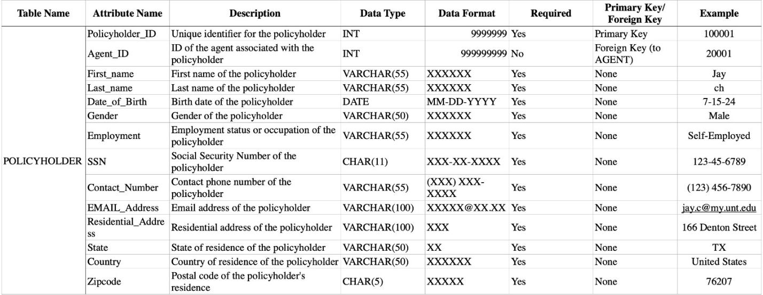

#Claim and Policy

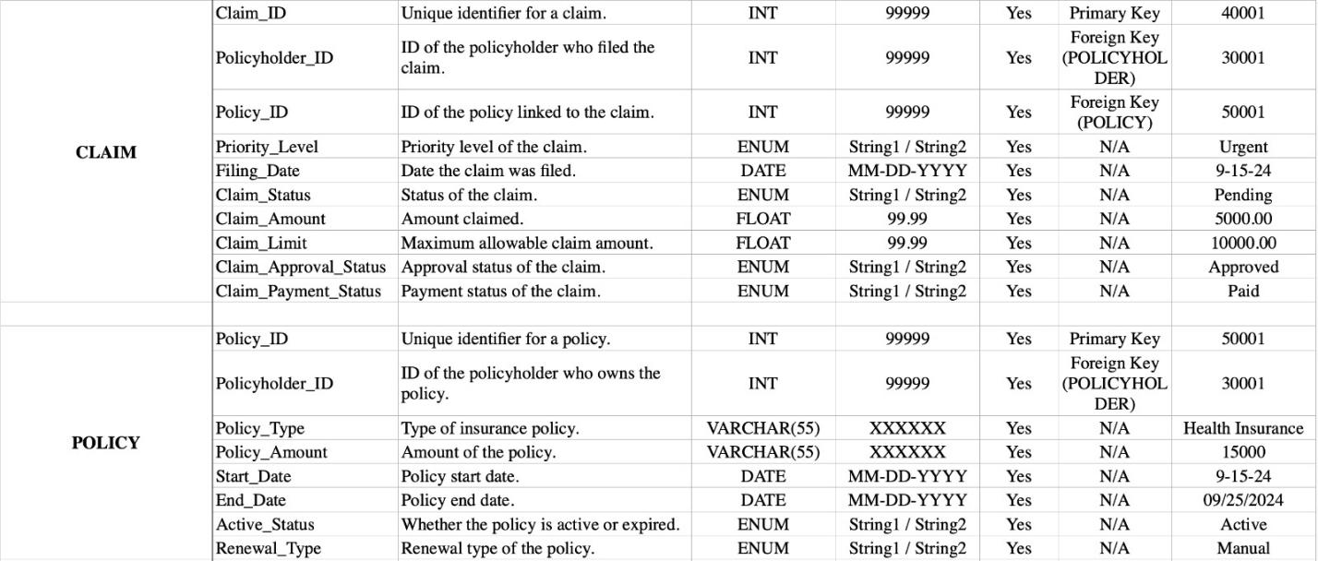

#Agent and Communication

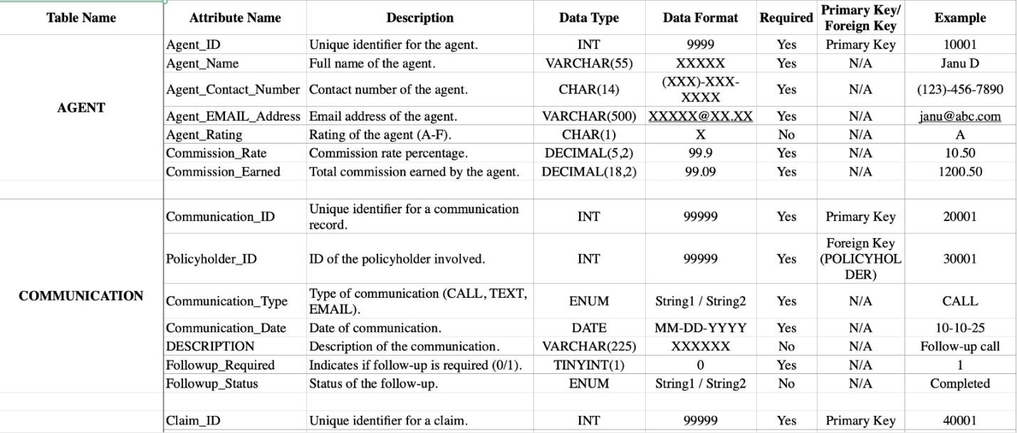

#Treatment and Policy Payment

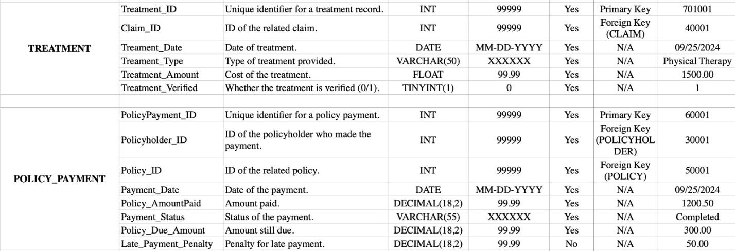

#Claim Settlements

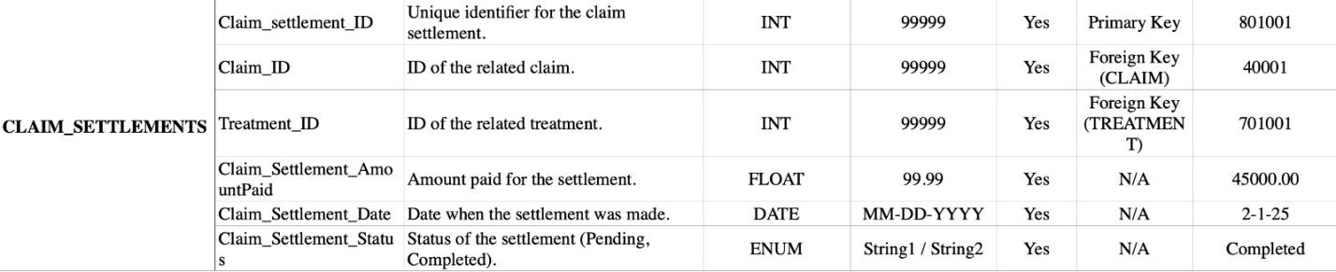

**Queries:**

**Create AGENT Table:**

USE insurance_claims;

CREATE TABLE AGENT (

Agent_ID INT PRIMARY KEY,

Agent_Name VARCHAR(55) NOT NULL,

Agent_Contact_Number CHAR(14) NOT NULL,

Agent_EMAIL_Address VARCHAR(500) NOT NULL,

Agent_Rating CHAR(1) NULL,

Commission_Rate DECIMAL(5,2) DEFAULT 0.00 NOT NULL,

Commission_Earned DECIMAL(18,2) DEFAULT 0.00 NOT NULL

);

**Insert values in AGENT table:**

/*---------------------------------INSERT AGENT TABLE-------------------------*/

INSERT INTO AGENT (Agent_ID, Agent_Name, Agent_Contact_Number, Agent_EMAIL_Address, Agent_Rating, Commission_Rate, Commission_Earned)

VALUES

(20101, 'Sarah Connor', '12345678901234', '[sarah.connor@example.com](mailto:sarah.connor@example.com)', 'A', 12.50, 15500.00),

(20102, 'John Reese', '23456789012345', '[john.reese@example.com](mailto:john.reese@example.com)', 'B', 10.00, 9500.00),

(20103, 'Derek Shepherd', '34567890123456', '[derek.shepherd@example.com](mailto:derek.shepherd@example.com)', 'A', 15.00, 12500.00),

(20104, 'Meredith Grey', '45678901234567', '[meredith.grey@example.com](mailto:meredith.grey@example.com)', 'A', 14.00, 11000.00),

(20105, 'Amelia Warner', '56789012345678', '[amelia.warner@example.com](mailto:amelia.warner@example.com)', 'C', 8.50, 4500.00),

(20106, 'Jackson Avery', '67890123456789', '[jackson.avery@example.com](mailto:jackson.avery@example.com)', 'B', 10.50, 7000.00),

(20107, 'April Kepner', '78901234567890', '[april.kepner@example.com](mailto:april.kepner@example.com)', 'B', 11.00, 9200.00),

(20108, 'Christina Yang', '89012345678901', '[christina.yang@example.com](mailto:christina.yang@example.com)', 'A', 13.00, 15250.00),

(20109, 'Richard Webber', '90123456789012', '[richard.webber@example.com](mailto:richard.webber@example.com)', 'A', 12.00, 14000.00),

(20110, 'Lexie Grey', '01234567890123', '[lexie.grey@example.com](mailto:lexie.grey@example.com)', 'B', 9.50, 6200.00),

(20111, 'Mark Sloan', '12312312312312', '[mark.sloan@example.com](mailto:mark.sloan@example.com)', 'A', 16.00, 18000.00),

(20112, 'Jo Wilson', '23423423423423', '[jo.wilson@example.com](mailto:jo.wilson@example.com)', 'B', 11.50, 9800.00),

(20113, 'Callie Torres', '34534534534534', '[callie.torres@example.com](mailto:callie.torres@example.com)', 'C', 7.00, 3500.00),

(20114, 'Arizona Robbins', '45645645645645', '[arizona.robbins@example.com](mailto:arizona.robbins@example.com)', 'B', 10.00, 7400.00),

(20115, 'Teddy Altman', '56756756756756', '[teddy.altman@example.com](mailto:teddy.altman@example.com)', 'A', 14.50, 15700.00),

(20116, 'Maggie Pierce', '67867867867867', '[maggie.pierce@example.com](mailto:maggie.pierce@example.com)', 'B', 11.00, 9600.00),

(20117, 'Owen Hunt', '78978978978978', '[owen.hunt@example.com](mailto:owen.hunt@example.com)', 'A', 12.50, 12500.00),

(20118, 'Miranda Bailey', '89089089089089', '[miranda.bailey@example.com](mailto:miranda.bailey@example.com)', 'A', 15.00, 17000.00),

(20119, 'Addison Montgomery', '90190190190190', '[addison.montgomery@example.com](mailto:addison.montgomery@example.com)', 'A', 14.00, 15000.00),

(20120, 'Izzie Stevens', '11223344556677', '[izzie.stevens@example.com](mailto:izzie.stevens@example.com)', 'B', 12.00, 9000.00),

(20121, 'George O’Malley', '22334455667788', '[george.omalley@example.com](mailto:george.omalley@example.com)', 'C', 9.00, 4000.00),

(20122, 'Bailey Tucker', '33445566778899', '[bailey.tucker@example.com](mailto:bailey.tucker@example.com)', 'B', 11.50, 8500.00),

(20123, 'Alex Karev', '44556677889900', '[alex.karev@example.com](mailto:alex.karev@example.com)', 'A', 13.50, 14250.00),

(20124, 'Catherine Fox', '55667788990011', '[catherine.fox@example.com](mailto:catherine.fox@example.com)', 'A', 12.00, 12000.00),

(20125, 'Eliza Minnick', '66778899001122', '[eliza.minnick@example.com](mailto:eliza.minnick@example.com)', 'C', 8.00, 3700.00);

**Query Screenshot:**

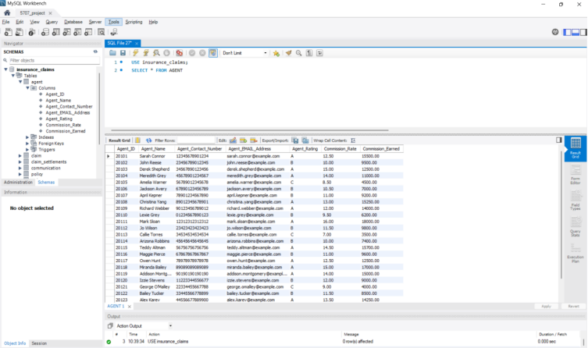

**Create POLICYHOLDER TABLE Table:**

/*-----------------CREATE POLICYHOLDER TABLE---------------------*/

USE insurance_claims;

CREATE TABLE POLICYHOLDER (

Policyholder_ID INT PRIMARY KEY,

Agent_ID INT NULL,

First_name VARCHAR(55) NOT NULL,

Last_name VARCHAR(55) NOT NULL,

Date_of_Birth DATE NOT NULL,

Gender VARCHAR(50) NOT NULL,

Employment VARCHAR(55) NOT NULL,

SSN CHAR(11) NOT NULL,

Contact_Number CHAR(14) NOT NULL,

EMAIL_Address VARCHAR(100) NOT NULL,

Residential_Address VARCHAR(100) NOT NULL,

State VARCHAR(50) NOT NULL,

Country VARCHAR(50) NOT NULL,

Zipcode VARCHAR(50) NOT NULL,

FOREIGN KEY (AGENT_ID) REFERENCES AGENT(AGENT_ID)

);

**Insert values in POLICY HOLDER table:**

INSERT INTO POLICYHOLDER (Policyholder_ID, Agent_ID, First_name, Last_name, Date_of_Birth, Gender, Employment, SSN, Contact_Number, EMAIL_Address, Residential_Address, State, Country, Zipcode)

VALUES

(101001, 20101, 'John', 'Doe', '1985-06-15', 'Male', 'Engineer', '123-45-6789', '1234567890', '[john.doe@example.com](mailto:john.doe@example.com)', '123 Elm St', 'California', 'USA', '90001'),

(101002, 20102, 'Jane', 'Smith', '1990-02-20', 'Female', 'Teacher', '234-56-7890', '9876543210', '[jane.smith@example.com](mailto:jane.smith@example.com)', '456 Oak St', 'Texas', 'USA', '73301'),

(101003, 20103, 'Alice', 'Johnson', '1988-11-05', 'Female', 'Accountant', '345-67-8901', '1122334455', '[alice.johnson@example.com](mailto:alice.johnson@example.com)', '789 Pine St', 'New York', 'USA', '10001'),

(101004, 20101, 'Bob', 'Brown', '1975-09-25', 'Male', 'Doctor', '456-78-9012', '5566778899', '[bob.brown@example.com](mailto:bob.brown@example.com)', '321 Maple St', 'Florida', 'USA', '33101'),

(101005, 20102, 'Charlie', 'Davis', '1995-03-15', 'Male', 'Student', '567-89-0123', '6677889900', '[charlie.davis@example.com](mailto:charlie.davis@example.com)', '654 Cedar St', 'Nevada', 'USA', '89001'),

(101006, 20103, 'Eve', 'Miller', '1982-08-10', 'Female', 'Designer', '678-90-1234', '7788990011', '[eve.miller@example.com](mailto:eve.miller@example.com)', '987 Birch St', 'Oregon', 'USA', '97001'),

(101007, 20101, 'Frank', 'Wilson', '1978-12-30', 'Male', 'Pilot', '789-01-2345', '8899001122', '[frank.wilson@example.com](mailto:frank.wilson@example.com)', '432 Fir St', 'California', 'USA', '90210'),

(101008, 20102, 'Grace', 'Lee', '1992-04-25', 'Female', 'Nurse', '890-12-3456', '9900112233', '[grace.lee@example.com](mailto:grace.lee@example.com)', '876 Walnut St', 'Texas', 'USA', '73344'),

(101009, 20103, 'Henry', 'Martinez', '1980-07-20', 'Male', 'Chef', '901-23-4567', '1231231234', '[henry.martinez@example.com](mailto:henry.martinez@example.com)', '543 Chestnut St', 'New York', 'USA', '10022'),

(101010, 20101, 'Ivy', 'Garcia', '1986-05-15', 'Female', 'Scientist', '012-34-5678', '2342342345', '[ivy.garcia@example.com](mailto:ivy.garcia@example.com)', '678 Ash St', 'Florida', 'USA', '33122'),

(101011, 20102, 'Jack', 'Rodriguez', '1993-10-01', 'Male', 'Architect', '123-45-6789', '3453453456', '[jack.rodriguez@example.com](mailto:jack.rodriguez@example.com)', '123 Holly St', 'Nevada', 'USA', '89109'),

(101012, 20103, 'Kathy', 'Lopez', '1991-01-14', 'Female', 'Engineer', '234-56-7890', '4564564567', '[kathy.lopez@example.com](mailto:kathy.lopez@example.com)', '456 Magnolia St', 'Oregon', 'USA', '97201'),

(101013, 20101, 'Leo', 'Gonzalez', '1979-06-10', 'Male', 'Technician', '345-67-8901', '5675675678', '[leo.gonzalez@example.com](mailto:leo.gonzalez@example.com)', '789 Alder St', 'California', 'USA', '90501'),

(101014, 20102, 'Mona', 'Perez', '1983-11-25', 'Female', 'Writer', '456-78-9012', '6786786789', '[mona.perez@example.com](mailto:mona.perez@example.com)', '321 Beech St', 'Texas', 'USA', '73401'),

(101015, 20103, 'Nate', 'Sanchez', '1989-03-15', 'Male', 'Journalist', '567-89-0123', '7897897890', '[nate.sanchez@example.com](mailto:nate.sanchez@example.com)', '654 Dogwood St', 'New York', 'USA', '10025'),

(101016, 20101, 'Olivia', 'Clark', '1996-07-20', 'Female', 'Artist', '678-90-1234', '8908908901', '[olivia.clark@example.com](mailto:olivia.clark@example.com)', '987 Elm St', 'Florida', 'USA', '33019'),

(101017, 20102, 'Paul', 'Lewis', '1981-12-30', 'Male', 'Banker', '789-01-2345', '1010101010', '[paul.lewis@example.com](mailto:paul.lewis@example.com)', '432 Maple St', 'Nevada', 'USA', '89135'),

(101018, 20103, 'Quinn', 'Walker', '1994-09-01', 'Female', 'Professor', '890-12-3456', '1111111111', '[quinn.walker@example.com](mailto:quinn.walker@example.com)', '876 Oak St', 'Oregon', 'USA', '97229'),

(101019, 20101, 'Rachel', 'Hall', '1987-02-28', 'Female', 'Lawyer', '901-23-4567', '2222222222', '[rachel.hall@example.com](mailto:rachel.hall@example.com)', '543 Pine St', 'California', 'USA', '90275'),

(101020, 20102, 'Steve', 'Allen', '1997-05-10', 'Male', 'Student', '012-34-5678', '3333333333', '[steve.allen@example.com](mailto:steve.allen@example.com)', '678 Cedar St', 'Texas', 'USA', '73315'),

(101021, 20103, 'Tina', 'Young', '1995-08-20', 'Female', 'Pharmacist', '123-45-6789', '4444444444', '[tina.young@example.com](mailto:tina.young@example.com)', '123 Birch St', 'New York', 'USA', '10109'),

(101022, 20101, 'Uma', 'Hernandez', '1984-12-15', 'Female', 'Scientist', '234-56-7890', '5555555555', '[uma.hernandez@example.com](mailto:uma.hernandez@example.com)', '456 Walnut St', 'Florida', 'USA', '33156'),

(101023, 20102, 'Victor', 'King', '1976-11-11', 'Male', 'Businessman', '345-67-8901', '6666666666', '[victor.king@example.com](mailto:victor.king@example.com)', '789 Chestnut St', 'Nevada', 'USA', '89141'),

(101024, 20103, 'Wendy', 'Scott', '1998-03-09', 'Female', 'Student', '456-78-9012', '7777777777', '[wendy.scott@example.com](mailto:wendy.scott@example.com)', '321 Ash St', 'Oregon', 'USA', '97301'),

(101025, 20101, 'Xavier', 'Torres', '1982-06-21', 'Male', 'Chef', '567-89-0123', '8888888888', '[xavier.torres@example.com](mailto:xavier.torres@example.com)', '654 Holly St', 'California', 'USA', '90506');

**Query Screenshot:**

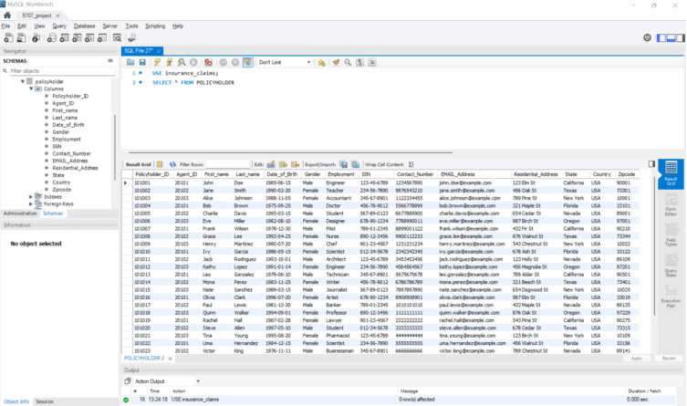

**Create POLICY Table**

/*-----------------CREATE POLICY TABLE---------------------*/

USE insurance_claims;

CREATE TABLE POLICY (

Policy_ID INT PRIMARY KEY,

Policyholder_ID INT NOT NULL,

Policy_Type VARCHAR(55) NOT NULL,

Policy_Amount VARCHAR(55) NOT NULL,

Start_Date DATE NOT NULL,

End_Date DATE NOT NULL,

Active_Status ENUM('Active', 'Expired') DEFAULT 'Active',

Renewal_Type ENUM('Automatic', 'Manual') DEFAULT 'Manual',

FOREIGN KEY (Policyholder_ID) REFERENCES POLICYHOLDER(Policyholder_ID)

);

**Insert values in POLICY table:**

INSERT INTO POLICY (Policy_ID, Policyholder_ID, Policy_Type, Policy_Amount, Start_Date, End_Date, Active_Status, Renewal_Type)

VALUES

(301001, 101001, 'Health Insurance', '50000', '2023-01-15', '2024-01-14', 'Active', 'Automatic'),

(301002, 101002, 'Health Insurance', '75000', '2023-04-20', '2024-04-19', 'Active', 'Automatic'),

(301003, 101003, 'Health Insurance', '60000', '2022-12-10', '2023-12-09', 'Active', 'Automatic'),

(301004, 101004, 'Health Insurance', '40000', '2023-08-05', '2024-08-04', 'Active', 'Automatic'),

(301005, 101005, 'Health Insurance', '35000', '2023-03-15', '2024-03-14', 'Active', 'Automatic'),

(301006, 101006, 'Health Insurance', '70000', '2023-05-20', '2024-05-19', 'Active', 'Automatic'),

(301007, 101007, 'Health Insurance', '62000', '2023-07-25', '2024-07-24', 'Active', 'Automatic'),

(301008, 101008, 'Health Insurance', '55000', '2023-02-01', '2024-01-31', 'Active', 'Automatic'),

(301009, 101009, 'Health Insurance', '67000', '2023-01-25', '2024-01-24', 'Active', 'Manual'),

(301010, 101010, 'Health Insurance', '20000', '2023-06-01', '2024-05-31', 'Active', 'Manual'),

(301011, 101011, 'Vision Insurance', '25000', '2023-07-15', '2024-07-14', 'Active', 'Automatic'),

(301012, 101012, 'Dental Insurance', '15000', '2023-03-01', '2024-02-29', 'Active', 'Automatic'),

(301013, 101013, 'Health Insurance', '20000', '2023-09-01', '2024-08-31', 'Active', 'Manual'),

(301014, 101014, 'Vision Insurance', '10000', '2023-01-01', '2024-01-01', 'Active', 'Automatic'),

(301015, 101015, 'Vision Insurance', '12000', '2023-02-01', '2024-01-31', 'Active', 'Manual'),

(301016, 101016, 'Vision Insurance', '8000', '2023-03-01', '2024-02-29', 'Active', 'Automatic'),

(301017, 101017, 'Health Insurance', '15000', '2023-04-01', '2024-03-31', 'Expired', 'Manual'),

(301018, 101018, 'Dental Insurance', '9000', '2023-05-01', '2024-04-30', 'Active', 'Manual'),

(301019, 101019, 'Health Insurance', '11000', '2023-06-01', '2024-05-31', 'Active', 'Automatic'),

(301020, 101020, 'Dental Insurance', '15000', '2023-01-15', '2024-01-14', 'Active', 'Automatic'),

(301021, 101021, 'Health Insurance', '17000', '2023-02-10', '2024-02-09', 'Active', 'Manual'),

(301022, 101022, 'Health Insurance', '12000', '2023-03-01', '2024-02-29', 'Active', 'Automatic'),

(301023, 101023, 'Dental Insurance', '18000', '2023-04-01', '2024-03-31', 'Active', 'Manual'),

(301024, 101024, 'Dental Insurance', '16000', '2023-05-10', '2024-05-09', 'Active', 'Automatic'),

(301025, 101025, 'Health Insurance', '20000', '2023-06-15', '2024-06-14', 'Active', 'Manual');

**Query Screenshot:**

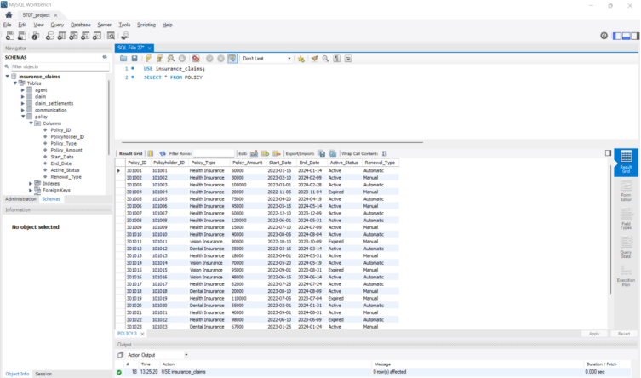

**Create POLICY PAYMENTS Table**

/*-----------------CREATE POLICY_PAYMENT TABLE---------------------*/

USE insurance_claims;

CREATE TABLE POLICY_PAYMENT (

PolicyPayment_ID INT PRIMARY KEY,

Policyholder_ID INT NOT NULL,

Policy_ID INT NOT NULL,

Payment_Date DATE NOT NULL,

Policy_AmountPaid DECIMAL(18,2) NOT NULL,

Payment_Status VARCHAR(55) NOT NULL,

Policy_Due_Amount DECIMAL(18,2) NOT NULL,

Late_Payment_Penalty DECIMAL(18,2) DEFAULT 0.00,

FOREIGN KEY (Policyholder_ID) REFERENCES POLICYHOLDER(Policyholder_ID),

FOREIGN KEY (Policy_ID) REFERENCES POLICY(Policy_ID)

);

**Insert values in POLICY PAYMENTS table:**

INSERT INTO POLICY_PAYMENT (PolicyPayment_ID, Policyholder_ID, Policy_ID, Payment_Date, Policy_AmountPaid, Payment_Status, Policy_Due_Amount, Late_Payment_Penalty)

VALUES

(501001, 101001, 301001, '2023-01-10', 50000, 'Paid', 0, 0),

(501002, 101002, 301002, '2023-02-15', 30000, 'Paid', 0, 0),

(501003, 101003, 301003, '2023-03-20', 90000, 'Paid', 10000, 0),

(501004, 101004, 301004, '2023-11-05', 15000, 'Pending', 5000, 200),

(501005, 101005, 301005, '2023-05-25', 75000, 'Paid', 0, 0),

(501006, 101006, 301006, '2023-06-10', 45000, 'Paid', 0, 0),

(501007, 101007, 301007, '2023-03-01', 55000, 'Paid', 5000, 0),

(501008, 101008, 301008, '2023-02-20', 110000, 'Paid', 10000, 0),

(501009, 101009, 301009, '2023-12-05', 12000, 'Paid', 3000, 100),

(501010, 101010, 301010, '2023-11-20', 40000, 'Paid', 0, 0),

(501011, 101011, 301011, '2023-10-05', 85000, 'Paid', 5000, 0),

(501012, 101012, 301012, '2023-09-30', 35000, 'Paid', 0, 0),

(501013, 101013, 301013, '2023-08-30', 18000, 'Paid', 0, 0),

(501014, 101014, 301014, '2023-07-20', 60000, 'Paid', 10000, 0),

(501015, 101015, 301015, '2023-05-15', 95000, 'Paid', 0, 0),

(501016, 101016, 301016, '2023-04-25', 48000, 'Paid', 0, 0),

(501017, 101017, 301017, '2023-03-20', 62000, 'Paid', 0, 0),

(501018, 101018, 301018, '2023-02-10', 20000, 'Paid', 0, 0),

(501019, 101019, 301019, '2023-01-20', 110000, 'Paid', 0, 0),

(501020, 101020, 301020, '2023-12-05', 55000, 'Paid', 0, 0),

(501021, 101021, 301021, '2023-11-10', 40000, 'Paid', 0, 0),

(501022, 101022, 301022, '2023-10-25', 95000, 'Paid', 3000, 200),

(501023, 101023, 301023, '2023-09-15', 67000, 'Paid', 0, 0),

(501024, 101024, 301024, '2023-08-25', 25000, 'Paid', 0, 0),

(501025, 101025, 301025, '2023-07-05', 38000, 'Paid', 0, 0);

**Query Screenshot**

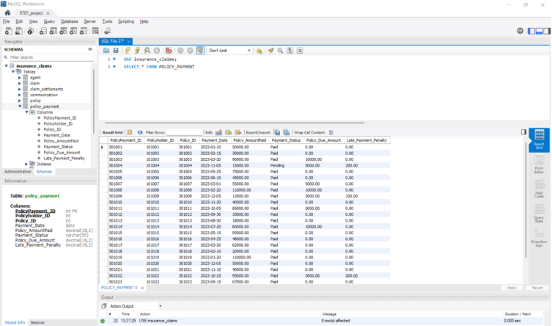

**Create CLAIM Table**

/*-----------------CREATE CLAIM TABLE---------------------*/

USE insurance_claims;

CREATE TABLE CLAIM (

Claim_ID INT PRIMARY KEY,

Policyholder_ID INT NOT NULL,

Policy_ID INT NOT NULL,

Priority_Level ENUM('Standard', 'Fast') DEFAULT 'Standard',

Filing_Date DATE NOT NULL,

Claim_Status ENUM('Started', 'Pending', 'Completed') DEFAULT 'Started',

CLaim_Amount DECIMAL(18,2) NOT NULL,

Claim_Limit DECIMAL(18,2) NOT NULL,

Claim_Approval_Status ENUM('Under Review', 'Approved', 'Rejected') DEFAULT 'Under Review',

Claim_Payment_Status ENUM('Pending', 'Paid', 'Rejected') DEFAULT 'Pending',

FOREIGN KEY (Policy_ID) REFERENCES POLICY(Policy_ID),

FOREIGN KEY (Policyholder_ID) REFERENCES POLICYHOLDER(Policyholder_ID)

);

**Insert values in CLAIM table:**

INSERT INTO CLAIM (Claim_ID, Policyholder_ID, Policy_ID, Priority_Level, Filing_Date, Claim_Status, Claim_Amount, Claim_Limit, Claim_Approval_Status, Claim_Payment_Status)

VALUES

(401001, 101001, 301001, 'Standard', '2023-09-10', 'Started', 45000, 50000, 'Under Review', 'Pending'),

(401002, 101002, 301002, 'Fast', '2023-10-15', 'Pending', 25000, 30000, 'Approved', 'Paid'),

(401003, 101003, 301003, 'Standard', '2023-07-20', 'Completed', 80000, 100000, 'Approved', 'Paid'),

(401004, 101004, 301004, 'Fast', '2023-08-01', 'Pending', 15000, 20000, 'Under Review', 'Pending'),

(401005, 101005, 301005, 'Standard', '2023-05-05', 'Started', 50000, 75000, 'Under Review', 'Pending'),

(401006, 101006, 301006, 'Fast', '2023-06-15', 'Pending', 30000, 45000, 'Approved', 'Paid'),

(401007, 101007, 301007, 'Standard', '2023-03-10', 'Completed', 55000, 60000, 'Approved', 'Paid'),

(401008, 101008, 301008, 'Standard', '2023-02-25', 'Pending', 100000, 120000, 'Under Review', 'Pending'),

(401009, 101009, 301009, 'Fast', '2023-12-01', 'Started', 12000, 15000, 'Under Review', 'Pending'),

(401010, 101010, 301010, 'Standard', '2023-11-15', 'Pending', 35000, 40000, 'Under Review', 'Pending'),

(401011, 101011, 301011, 'Fast', '2023-10-01', 'Completed', 85000, 90000, 'Approved', 'Paid'),

(401012, 101012, 301012, 'Standard', '2023-09-20', 'Started', 30000, 35000, 'Under Review', 'Pending'),

(401013, 101013, 301013, 'Fast', '2023-08-25', 'Completed', 15000, 18000, 'Approved', 'Paid'),

(401014, 101014, 301014, 'Standard', '2023-07-15', 'Pending', 60000, 70000, 'Under Review', 'Pending'),

(401015, 101015, 301015, 'Standard', '2023-05-10', 'Started', 85000, 95000, 'Under Review', 'Pending'),

(401016, 101016, 301016, 'Fast', '2023-04-20', 'Pending', 45000, 48000, 'Approved', 'Paid'),

(401017, 101017, 301017, 'Standard', '2023-03-25', 'Started', 55000, 62000, 'Under Review', 'Pending'),

(401018, 101018, 301018, 'Fast', '2023-02-15', 'Pending', 18000, 20000, 'Approved', 'Paid'),

(401019, 101019, 301019, 'Standard', '2023-01-30', 'Completed', 95000, 110000, 'Approved', 'Paid'),

(401020, 101020, 301020, 'Fast', '2023-12-10', 'Started', 50000, 55000, 'Under Review', 'Pending'),

(401021, 101021, 301021, 'Standard', '2023-11-05', 'Completed', 35000, 40000, 'Approved', 'Paid'),

(401022, 101022, 301022, 'Fast', '2023-10-15', 'Pending', 85000, 98000, 'Under Review', 'Pending'),

(401023, 101023, 301023, 'Standard', '2023-09-25', 'Started', 60000, 67000, 'Under Review', 'Pending'),

(401024, 101024, 301024, 'Fast', '2023-08-05', 'Completed', 24000, 25000, 'Approved', 'Paid'),

(401025, 101025, 301025, 'Standard', '2023-07-01', 'Pending', 30000, 38000, 'Under Review', 'Pending');

**Query Screenshot**

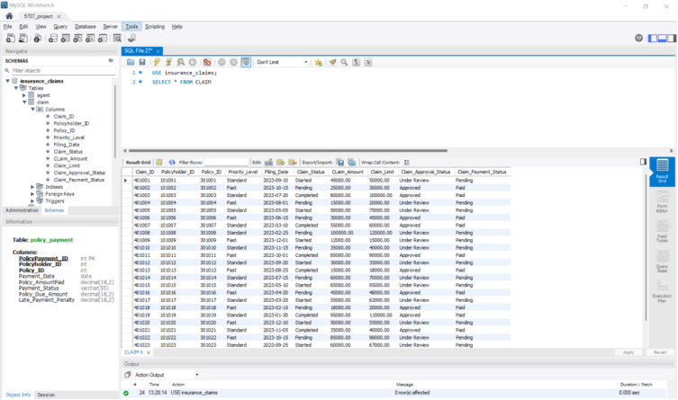

**Create COMMUNICATION Table**

/*-----------------CREATE COMMUNICATION TABLE---------------------*/

USE insurance_claims;

CREATE TABLE COMMUNICATION (

Communication_ID INT PRIMARY KEY,

Policyholder_ID INT NOT NULL,

Communication_Type ENUM('CALL', 'TEXT', 'EMAIL') DEFAULT 'CALL',

Communication_Date DATE NOT NULL,

DESCRIPTION VARCHAR(225) NOT NULL,

Followup_Required TINYINT(1) DEFAULT 0,

Followup_Status ENUM('Pending', 'Completed') DEFAULT 'Pending',

FOREIGN KEY (Policyholder_ID) REFERENCES Policyholder(Policyholder_ID)

);

**Insert values in COMMUNICATION table:**

INSERT INTO COMMUNICATION (Communication_ID, Policyholder_ID, Communication_Type, Communication_Date, DESCRIPTION, Followup_Required, Followup_Status)

VALUES

(601001, 101001, 'CALL', '2023-01-15', 'Discussed policy renewal', 1, 'Completed'),

(601002, 101002, 'EMAIL', '2023-02-10', 'Sent claim documents', 0, 'Completed'),

(601003, 101003, 'TEXT', '2023-03-05', 'Reminder for payment', 1, 'Pending'),

(601004, 101004, 'CALL', '2023-04-20', 'Explained claim process', 1, 'Completed'),

(601005, 101005, 'EMAIL', '2023-05-10', 'Policy update sent', 0, 'Completed'),

(601006, 101006, 'CALL', '2023-06-25', 'Asked for missing documents', 1, 'Pending'),

(601007, 101007, 'TEXT', '2023-07-15', 'Reminder for premium due', 0, 'Completed'),

(601008, 101008, 'CALL', '2023-08-05', 'Follow-up on claim status', 1, 'Pending'),

(601009, 101009, 'EMAIL', '2023-09-01', 'Policy terms shared', 0, 'Completed'),

(601010, 101010, 'TEXT', '2023-10-10', 'Reminder for document submission', 1, 'Pending'),

(601011, 101011, 'CALL', '2023-11-20', 'Claim settlement discussion', 1, 'Completed'),

(601012, 101012, 'EMAIL', '2023-12-15', 'Policy renewal confirmation', 0, 'Completed'),

(601013, 101013, 'CALL', '2024-01-05', 'Clarified premium amount', 1, 'Pending'),

(601014, 101014, 'TEXT', '2024-02-20', 'Premium payment reminder', 0, 'Completed'),

(601015, 101015, 'EMAIL', '2024-03-15', 'Claim status update', 0, 'Completed'),

(601016, 101016, 'CALL', '2024-04-10', 'Explained payment terms', 1, 'Completed'),

(601017, 101017, 'TEXT', '2024-05-01', 'Document verification reminder', 0, 'Completed'),

(601018, 101018, 'EMAIL', '2024-06-15', 'Policy cancellation inquiry', 1, 'Pending'),

(601019, 101019, 'CALL', '2024-07-10', 'Explained renewal process', 1, 'Completed'),

(601020, 101020, 'TEXT', '2024-08-05', 'Claim process explanation', 0, 'Completed'),

(601021, 101021, 'EMAIL', '2024-09-01', 'Policy expiration notice', 0, 'Completed'),

(601022, 101022, 'CALL', '2024-10-15', 'Follow-up on claim status', 1, 'Pending'),

(601023, 101023, 'TEXT', '2024-11-10', 'Premium reminder', 0, 'Completed'),

(601024, 101024, 'EMAIL', '2024-12-01', 'Claim rejection explanation', 0, 'Completed'),

(601025, 101025, 'CALL', '2024-12-20', 'Final claim settlement discussion', 1, 'Completed');

**Query Screenshot**

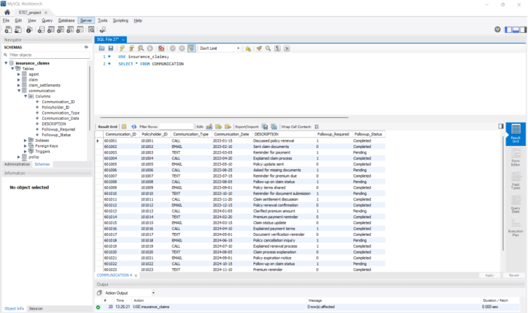

**Create TREATMENT Table**

/*-----------------CREATE TREATMENT TABLE---------------------*/

USE insurance_claims;

CREATE TABLE TREATMENT (

Treatment_ID INT PRIMARY KEY,

Claim_ID INT NOT NULL,

Treament_Date DATE NOT NULL,

Treament_Type VARCHAR(50) NOT NULL,

Treatment_Amount DECIMAL(18,2) NOT NULL,

Treatment_Verified TINYINT(1) DEFAULT 0, -- 0: Not Verified, 1: Verified

FOREIGN KEY (Claim_ID) REFERENCES CLAIM(Claim_ID)

);

**Insert values in TREATMENT table:**

INSERT INTO TREATMENT (Treatment_ID, Claim_ID, Treament_Date, Treament_Type, Treatment_Amount, Treatment_Verified)

VALUES

(701001, 401001, '2023-01-20', 'Medical Surgery', 45000, 1),

(701002, 401002, '2023-02-25', 'Physiotherapy', 12000, 1),

(701003, 401003, '2023-03-15', 'Hospitalization', 70000, 1),

(701004, 401004, '2023-04-10', 'Dental Care', 8000, 0),

(701005, 401005, '2023-05-20', 'Eye Surgery', 50000, 1),

(701006, 401006, '2023-06-15', 'Cardiology Checkup', 15000, 1),

(701007, 401007, '2023-07-05', 'Cancer Treatment', 90000, 1),

(701008, 401008, '2023-08-10', 'General Checkup', 3000, 0),

(701009, 401009, '2023-09-15', 'Emergency Care', 15000, 1),

(701010, 401010, '2023-10-25', 'Orthopedic Surgery', 35000, 1),

(701011, 401011, '2023-11-05', 'ENT Treatment', 8000, 1),

(701012, 401012, '2023-12-15', 'Medical Tests', 5000, 1),

(701013, 401013, '2024-01-10', 'Psychiatric Therapy', 20000, 1),

(701014, 401014, '2024-02-05', 'Physiotherapy', 10000, 1),

(701015, 401015, '2024-03-01', 'Heart Surgery', 80000, 1),

(701016, 401016, '2024-04-10', 'Cancer Treatment', 60000, 1),

(701017, 401017, '2024-05-15', 'Hospital Stay', 25000, 0),

(701018, 401018, '2024-06-05', 'Eye Care', 12000, 1),

(701019, 401019, '2024-07-01', 'Dental Surgery', 20000, 1),

(701020, 401020, '2024-08-10', 'Orthopedic Checkup', 18000, 0),

(701021, 401021, '2024-09-20', 'Heart Checkup', 15000, 1),

(701022, 401022, '2024-10-01', 'General Surgery', 40000, 1),

(701023, 401023, '2024-11-25', 'Emergency Surgery', 35000, 1),

(701024, 401024, '2024-12-05', 'Physical Therapy', 10000, 0),

(701025, 401025, '2024-12-15', 'Psychiatric Care', 15000, 1);

**Query Screenshot**

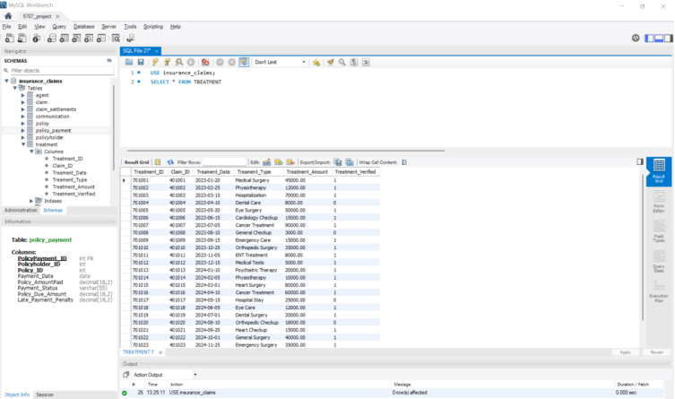

**Create CLAIM SETTLEMENTS Table**

/*-----------------CREATE CLAIM_SETTLEMENTS TABLE---------------------*/

USE insurance_claims;

CREATE TABLE CLAIM_SETTLEMENTS (

Claim_settlement_ID INT PRIMARY KEY,

Claim_ID INT NOT NULL,

Treatment_ID INT NOT NULL,

Claim_Settlement_AmountPaid DECIMAL(18,2) NOT NULL,

Claim_Settlement_Date DATE NOT NULL,

Claim_Settlement_Status ENUM('Pending', 'Completed') DEFAULT 'Pending',

FOREIGN KEY (Claim_ID) REFERENCES CLAIM(Claim_ID),

FOREIGN KEY (Treatment_ID) REFERENCES TREATMENT(Treatment_ID)

);

**Insert values in CLAIM SETTLEMENTS table:**

INSERT INTO CLAIM_SETTLEMENTS (Claim_settlement_ID, Claim_ID, Treatment_ID, Claim_Settlement_AmountPaid, Claim_Settlement_Date, Claim_Settlement_Status)

VALUES

(801001, 401001, 701001, 45000, '2023-02-01', 'Completed'),

(801002, 401002, 701002, 12000, '2023-03-01', 'Completed'),

(801003, 401003, 701003, 70000, '2023-04-05', 'Completed'),

(801004, 401004, 701004, 8000, '2023-05-10', 'Pending'),

(801005, 401005, 701005, 50000, '2023-06-20', 'Completed'),

(801006, 401006, 701006, 15000, '2023-07-15', 'Completed'),

(801007, 401007, 701007, 90000, '2023-08-01', 'Completed'),

(801008, 401008, 701008, 3000, '2023-09-10', 'Pending'),

(801009, 401009, 701009, 15000, '2023-10-15', 'Completed'),

(801010, 401010, 701010, 35000, '2023-11-25', 'Completed'),

(801011, 401011, 701011, 8000, '2023-12-05', 'Completed'),

(801012, 401012, 701012, 5000, '2024-01-10', 'Completed'),

(801013, 401013, 701013, 20000, '2024-02-15', 'Completed'),

(801014, 401014, 701014, 10000, '2024-03-10', 'Completed'),

(801015, 401015, 701015, 80000, '2024-04-05', 'Completed'),

(801016, 401016, 701016, 60000, '2024-05-10', 'Completed'),

(801017, 401017, 701017, 25000, '2024-06-01', 'Pending'),

(801018, 401018, 701018, 12000, '2024-07-20', 'Completed'),

(801019, 401019, 701019, 20000, '2024-08-15', 'Completed'),

(801020, 401020, 701020, 18000, '2024-09-05', 'Completed'),

(801021, 401021, 701021, 15000, '2024-10-25', 'Completed'),

(801022, 401022, 701022, 40000, '2024-11-10', 'Completed'),

(801023, 401023, 701023, 35000, '2024-12-01', 'Completed'),

(801024, 401024, 701024, 10000, '2024-12-15', 'Pending'),

(801025, 401025, 701025, 15000, '2025-01-05', 'Completed');

**Query Screenshot**

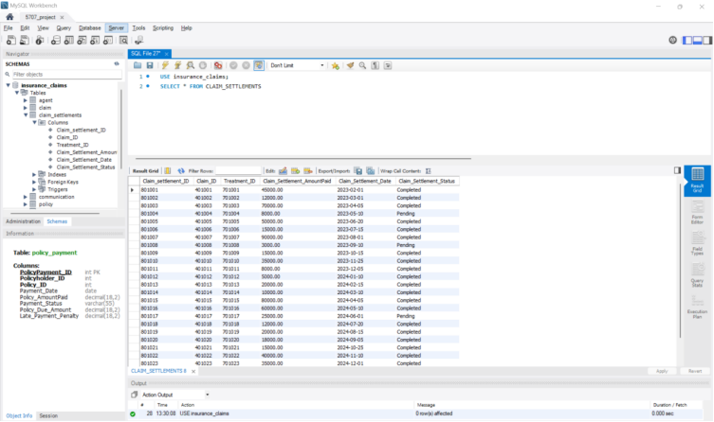

**Data Analysis 1**

Statement: Find the total claim amount and average claim amount grouped by policy type.

SQL command explanation:

* Command “USE insurance claims” Used to select and switch to the insurance claims database for executing subsequent queries.
* Command COUNT(column_name) Used to count the number of rows for a specific column, providing the total number of records that meet the query conditions.
* Command AS: Used to rename a column or expression for better readability, e.g., SUM(Claim_Amount) AS Total_Claim_Amount.
* Command GROUP BY p.Policy_Type Used to group the query results by the Policy_Type column, enabling aggregation functions to calculate totals or averages for each group.
* Command ORDER BY Total_Claim_Amount DESC Used to sort the query results in descending order based on the Total_Claim_Amount.

SQL Query

/*----------------------------------------------------- Data Analysis 1:------------------------------------------*/

USE insurance_claims;

SELECT p.Policy_Type, COUNT(c.Claim_ID) AS Total_Claims, SUM(c.CLaim_Amount) AS Total_Claim_Amount, AVG(c.CLaim_Amount) AS Average_Claim_Amount

FROM CLAIM c JOIN POLICY p ON c.Policy_ID = p.Policy_ID

GROUP BY p.Policy_Type ORDER BY Total_Claim_Amount DESC;

/*----------------------------------------------------------------------------------------------------------------------*/

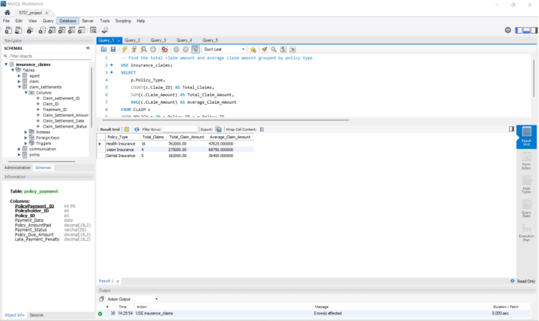

**Data Analysis 2**

Statement: Find policy types where the total claim amount exceeds $10,000.

SQL command explanation:

* Command “USE insurance_claims” Used to select and activate the insurance_claims database for executing the query.
* Command SELECT p.Policy_Type, SUM(c.Claim_Amount) AS Total_Claim_Amount: Retrieves the Policy_Type from the POLICY table and calculates the total claim amount (SUM) for each policy type, renaming it as Total_Claim_Amount.
* Command FROM CLAIM c JOIN POLICY p ON c.Policy_ID = p.Policy_ID Combines the CLAIM and POLICY tables using an inner join based on the Policy_ID column to associate claims with their policies.
* Command GROUP BY p.Policy_Type Aggregates the query results by Policy_Type, enabling calculations like SUM to be applied to each policy type group.
* Command HAVING SUM(c.Claim_Amount) > 10000 Filters the grouped results to include only those policy types where the total claim amount exceeds 10,000.

SQL Query

/*----------------------------------------------------- Data Analysis 2:------------------------------------------*/

USE insurance_claims;

SELECT p.Policy_Type, SUM(c.CLaim_Amount) AS Total_Claim_Amount

FROM CLAIM c JOIN POLICY p ON c.Policy_ID = p.Policy_ID

GROUP BY p.Policy_Type

HAVING SUM(c.CLaim_Amount) > 10000;

/*----------------------------------------------------------------------------------------------------------------------*/

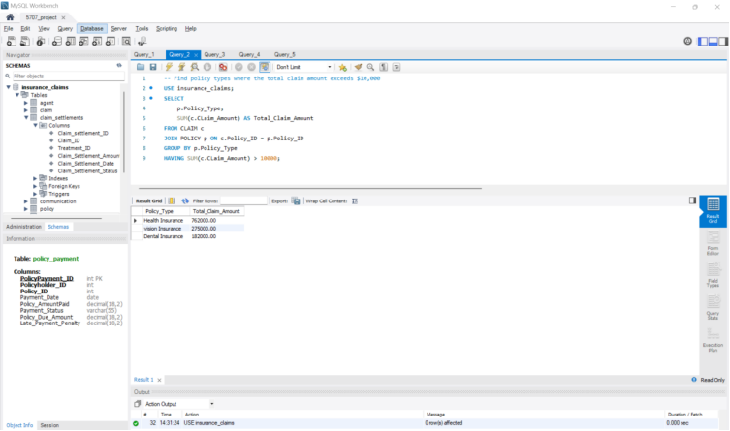

**Data Analysis 3**

Statement: Find pairs of policyholders who share the same agent.

SQL command explanation:

* Command “USE insurance_claims” Used to select and activate the insurance_claims database to execute the query.
* Command SELECT p1.Policyholder_ID AS Policyholder1_ID, p2.Policyholder_ID AS Policyholder2_ID, p1.Agent_ID Retrieves the IDs of two policyholders (Policyholder1_ID and Policyholder2_ID) and their associated agent's ID (Agent_ID). The aliases Policyholder1_ID and Policyholder2_ID are used for clarity.
* Command FROM POLICYHOLDER p1 JOIN POLICYHOLDER p2 ON p1.Agent_ID = p2.Agent_ID Performs a self-join on the POLICYHOLDER table, linking records where the Agent_ID is the same, to find pairs of policyholders associated with the same agent.
* Command WHERE p1.Policyholder_ID <> p2.Policyholder_ID: Ensures that the query excludes cases where both policyholders are the same person by filtering out rows where Policyholder_ID in p1 equals Policyholder_ID in p2.
* Purpose: The query identifies pairs of different policyholders managed by the same agent, which could be useful for analyzing agent performance or identifying cross-selling opportunities.

SQL Query

/*----------------------------------------------------- Data Analysis 3:------------------------------------------*/

USE insurance_claims;

SELECT p1.Policyholder_ID AS Policyholder1_ID, p2.Policyholder_ID AS Policyholder2_ID, p1.Agent_ID

FROM POLICYHOLDER p1 JOIN POLICYHOLDER p2 ON p1.Agent_ID = p2.Agent_ID

WHERE p1.Policyholder_ID <> p2.Policyholder_ID;

/*----------------------------------------------------------------------------------------------------------------------*/

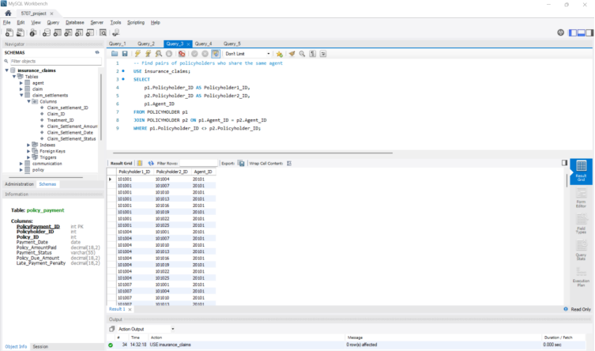

**Data Analysis 4**

Statement: Policy with the Minimum Claim Amount.

SQL command explanation:

* Command “USE insurance_claims” Activates the insurance_claims database to execute the query.
* Command SELECT c.Policy_ID, p.Policy_Type, MIN(c.Claim_Amount) AS Minimum_Claim_Amount Retrieves the Policy_ID, Policy_Type, and the smallest claim amount (MIN) for each policy. The smallest claim amount is renamed as Minimum_Claim_Amount.
* Command FROM CLAIM c JOIN POLICY p ON c.Policy_ID = p.Policy_ID Joins the CLAIM table with the POLICY table using the Policy_ID to associate claims with their respective policies.
* Command GROUP BY c.Policy_ID, p.Policy_Type Groups the results by both Policy_ID and Policy_Type, allowing the MIN function to compute the smallest claim amount for each policy group.
* Command ORDER BY Minimum_Claim_Amount ASC Sorts the grouped results in ascending order based on the Minimum_Claim_Amount. Policies with lower claim amounts appear first.
* Command LIMIT 1 Limits the output to only the top row, which represents the policy with the lowest claim amount.
* Purpose Identifies the policy with the minimum claim amount across all policies, useful for analyzing the smallest claims and associated policy types.

SQL Query

/*----------------------------------------------------- Data Analysis 4:------------------------------------------*/

USE insurance_claims;

SELECT c.Policy_ID, p.Policy_Type, MIN(c.CLaim_Amount) AS Minimum_Claim_Amount

FROM CLAIM c JOIN POLICY p ON c.Policy_ID = p.Policy_ID

GROUP BY c.Policy_ID, p.Policy_Type

ORDER BY Minimum_Claim_Amount

ASC LIMIT 1; -- Only the policy with the lowest claim amount

/*----------------------------------------------------------------------------------------------------------------------*/

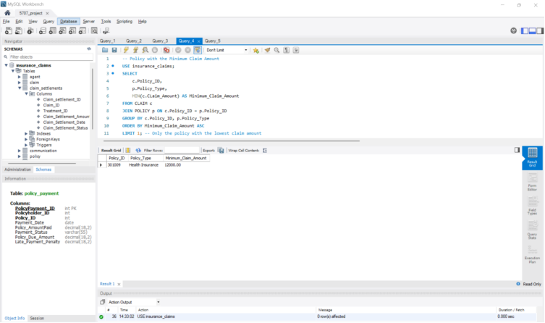

**Data Analysis 5**

Statement: Agent with the Highest Total Commission Earned.

SQL command explanation:

* Command “USE insurance_claims” Activates the insurance_claims database to ensure the query is executed within the correct context.
* Command SELECT Agent_ID, Agent_Name, MAX(Commission_Earned) AS Max_Commission Retrieves the Agent_ID, Agent_Name, and the maximum commission earned (MAX) by each agent. The maximum commission is renamed as Max_Commission.
* Command FROM AGENT Specifies the AGENT table as the source of the data for the query.
* Command GROUP BY Agent_ID, Agent_Name Groups the data by agent identifiers (Agent_ID) and names (Agent_Name), allowing the MAX function to compute the maximum commission for each agent group.
* Command ORDER BY Max_Commission DESC Sorts the grouped results in descending order of Max_Commission, showing agents with the highest commissions at the top.
* Purpose: Identifies agents and highlights the maximum commission earned by each, sorted to reveal the top earners, useful for performance evaluations and incentive analysis.

SQL Query

/*----------------------------------------------------- Data Analysis 5:------------------------------------------*/

USE insurance_claims;

SELECT Agent_ID, Agent_Name, MAX(Commission_Earned) AS Max_Commission

FROM AGENT

GROUP BY Agent_ID, Agent_Name

ORDER BY Max_Commission DESC;

/*----------------------------------------------------------------------------------------------------------------------*/

